1. Login to OEM as oracledba first
2. Pick search Target: DPPRD02
3. Top Right click on ORACLEDBA dropdown and click Log out

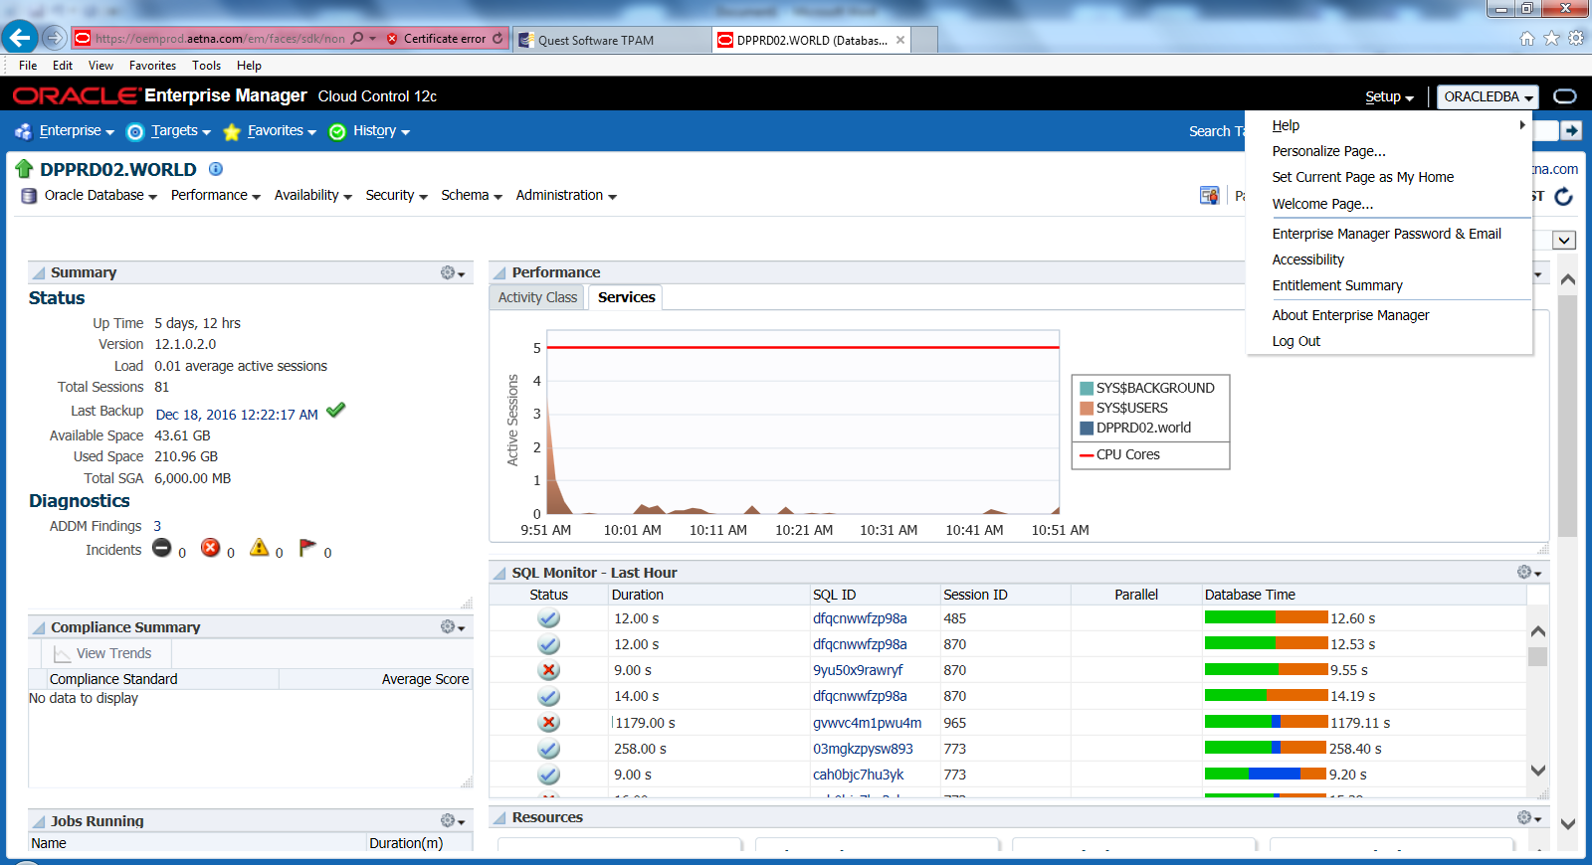

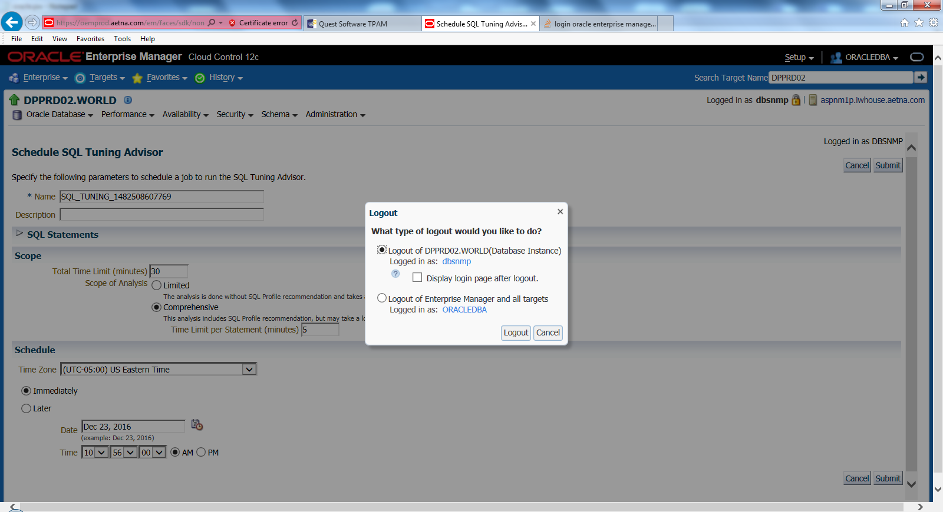

Select checkbox Display login page after logout

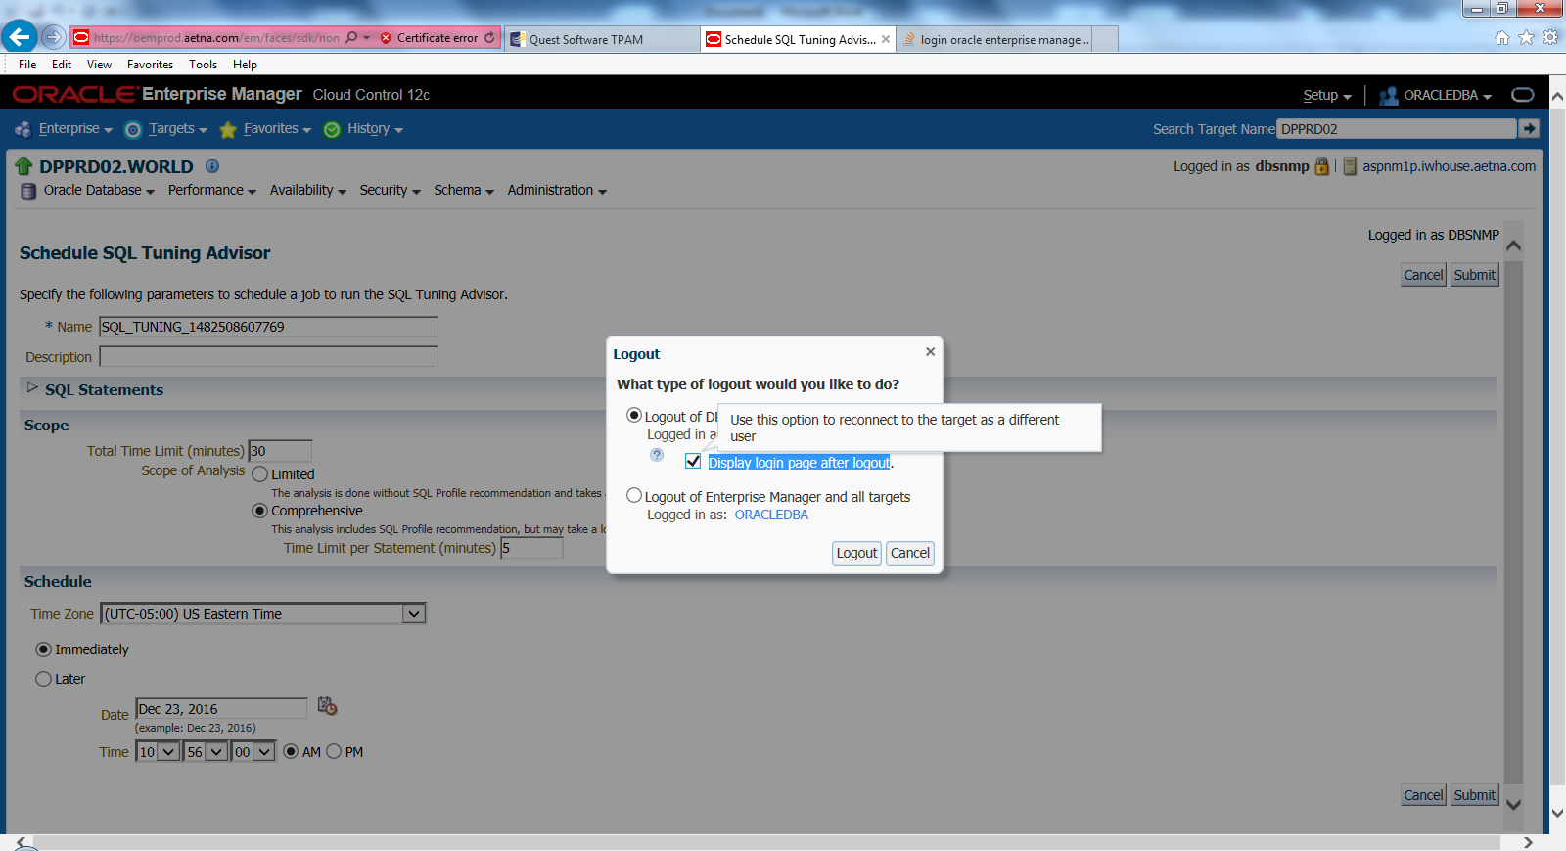

Select new Radio Button and enter specific Oracle account and password

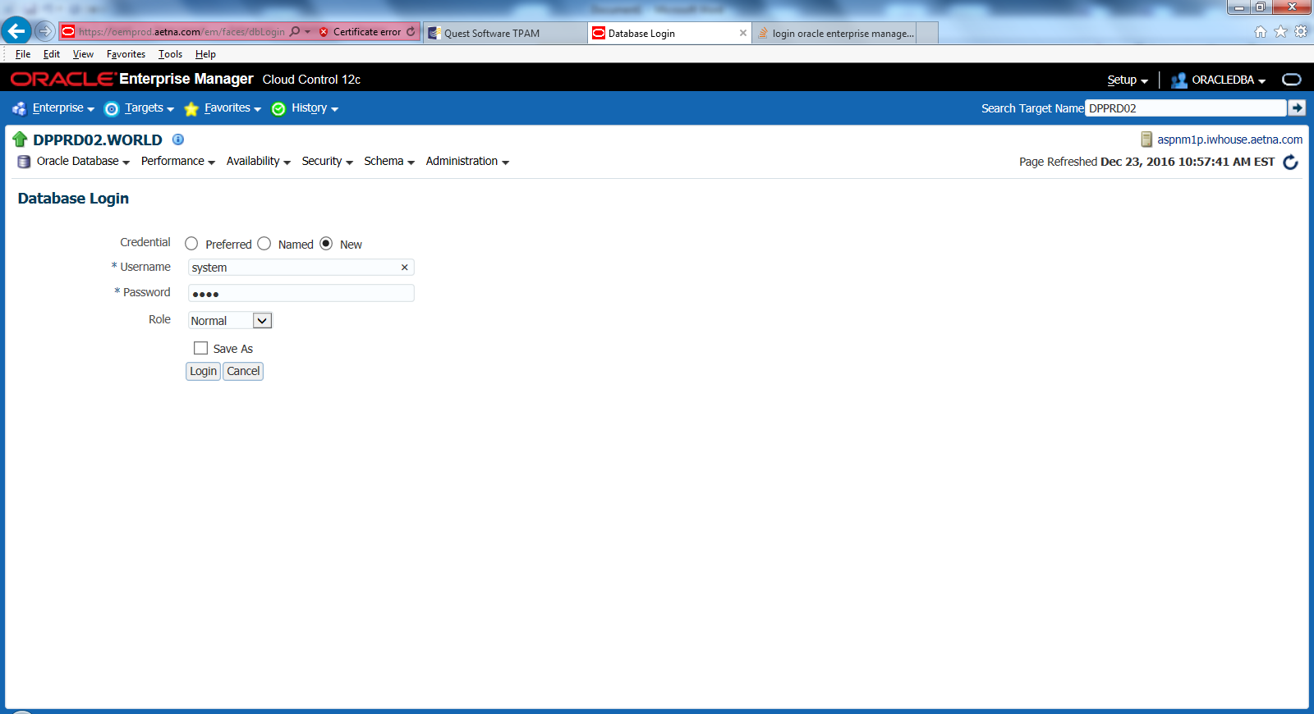

Go to Performance Menu and select Top activity. Select long running query session with Schedule SQL Tuning Advisor and click GO. This will start running Tuning Advisor session .

